Assignment #2: Number Sliding Puzzle Zurabi Todua
Create a sliding puzzle game where players arrange numbers in ascending order. The program should allow players to select grid sizes (3x3, 4x4, or 5x5) through a menu system. Initialize the grid with sequential numbers and one empty space (0). Players move tiles using WASD keys (W: up, A: left, S: down, D: right). Validate each move to ensure it's possible (adjacent to empty space) and within grid boundaries. Display the updated grid after each valid move with proper spacing. Track the number of moves made and maintain high scores for each grid size. If the user instead of WASD will select R letter then display menu options using switch statement:
- Start new game
- Change grid size
- Show current score
- Shuffle current grid
- Restart game
- Resume
- Quit. Check for win condition (numbers in ascending order, empty space at end).
Requirements:
- Define maximum grid size (5x5) as constant
- Use either static arrays or vectors (of your choice)
- Implement move validation and tracking
- Create shuffle function for random but solvable configurations
- Format grid display with proper spacing
- Store and display high scores per grid size
- Document code with comments and include screenshots on PDF

Step 1:
At the beginning of the program I included all the required preprocessor directives and declared necessary function prototypes and global variables. I named every function and variable according to their use to make it clear and easy to read. Also added comments for their exact use cases and specific niches. (I had to make the high_scores[] values INT_MAX, so that later when I compared, I got the correct high score which is supposed to be the smallest number.)
Step 2:
First I made a menu() function that showed the user their given options and also asked for a choice, which then gets processed by a switch operator, which I put into the options() function.
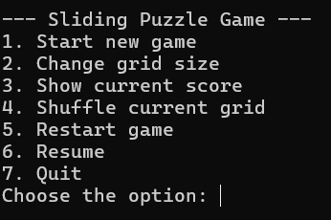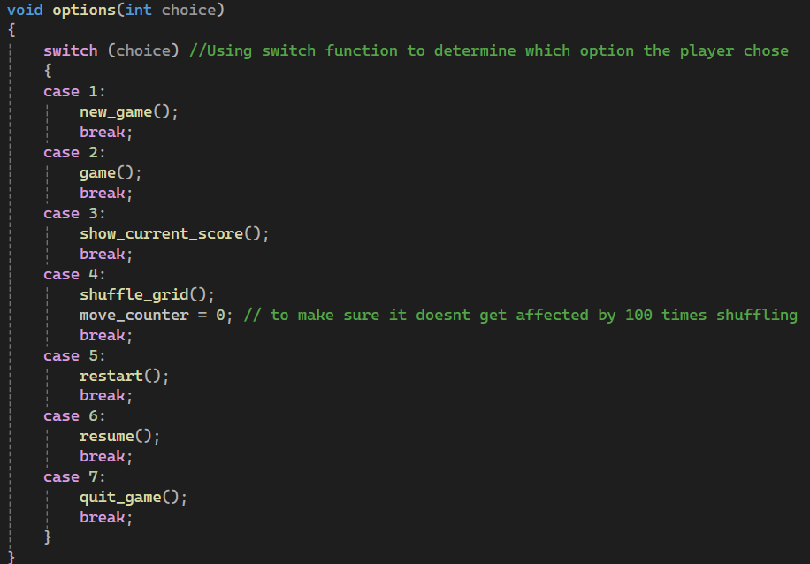
Step 3:
After assigning each option to their own functions, I had to write these functions’ script, starting with the main game() function. It manages the most important parts of the game of asking the user their preffered grid size, generating a grid based on the size, shuffling it with an algorithm, displaying it and then starting the actual part of the game. We ask the user which grid size they want to play and then, ask them to input out of 5 different characters that either move around the puzzle or open up the menu. After we get the character, we start up a while loop which runs before either the user wins (We use the win_checker() function at the start of the loop to make sure of this) or exits out. In the loop we use null_coordinates() to find the exact coordinates of the empty tile and then give it to the move_tile() function which takes care of swapping the places of empty and adjacent tiles. With every move it gives us an updated move counter and grid, while also having the option to give a congratulatory message and updating the highest scores if needed. 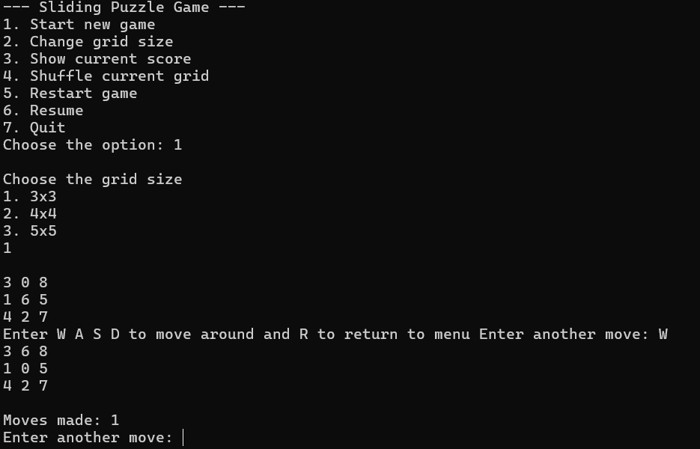
After winning the player can either go to the menu again or exit out of the game.
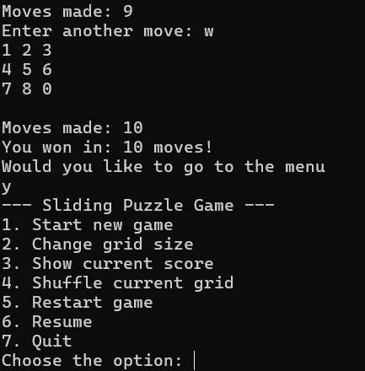
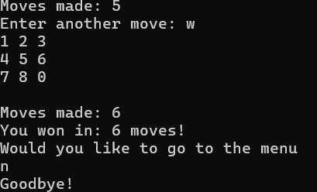
Step 4:
After the game() function we make sure to write all of the important little functions such as the change_grid_size() which uses switch case to find which size the player wants to use.
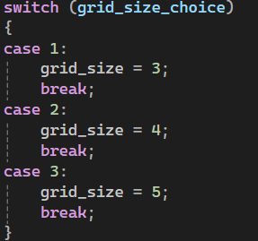
The original_grid() function which just generates a basic nxn grid based on the size and then puts ascending values with an empty tile at the end.
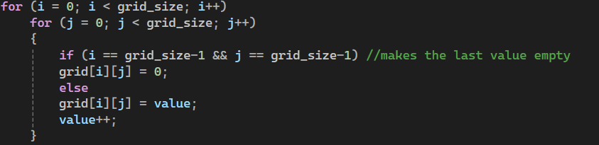
The shuffle_grid() function which uses a randomizer that picks characters out of an already predetermined char array of moves and then uses those moves on the grid a 100 times to make it as random as possible.
The display_grid() function which just goes through the grid and prints out the letters.
Step 5:
The hardest part of this whole assignment has to be taking care of the actual movements of the tiles. For this I had to create two functions which first found the coordinates of the empty tile by comparing every grid element to a 0. After finding that tile we save the coordinates to use in the move_tile() function.
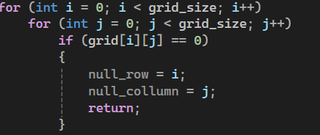
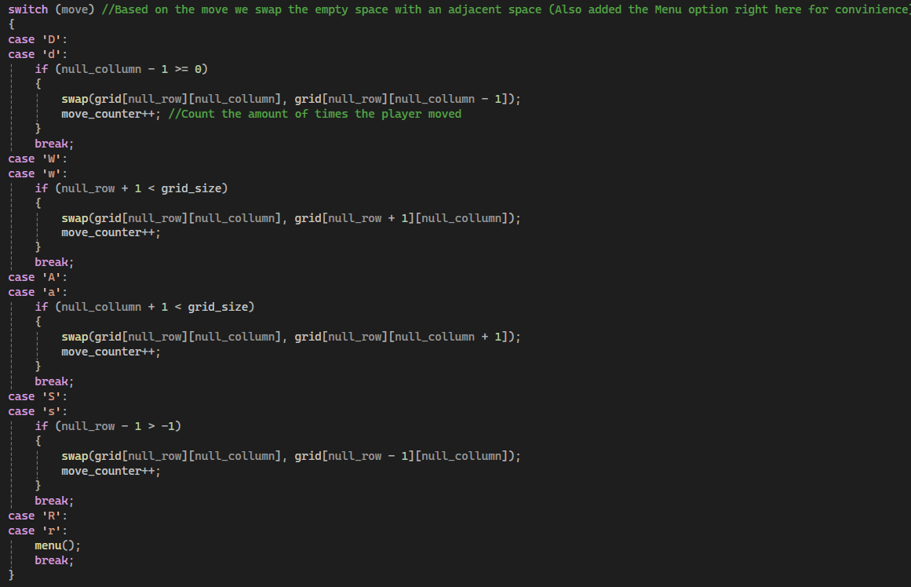
In move_tile() we again use a switch case that finds out what letter the user inputted (we make sure to include both the capital and small letters to make it case insensitive). After finding the coordinates of the empty space we then use switch to find where the numbers are supposed to be swapped. We calculate this based on rows and columns for each case. But we can not forget to check if the move can even be made, that’s why we use an if function just in case if the user messes up. If they do mess up then we don’t change the grid or add a number to the move counter. In case the user inputted ‘r’/’R’ then we just take them to the menu.

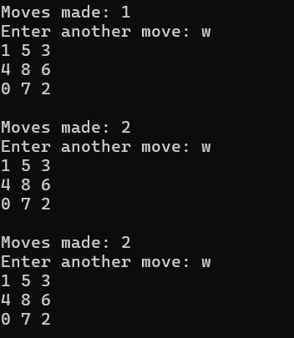
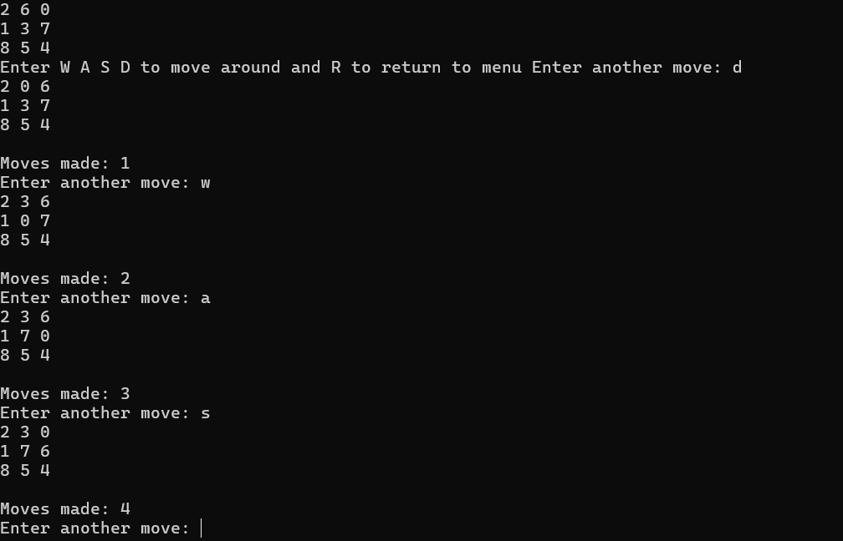

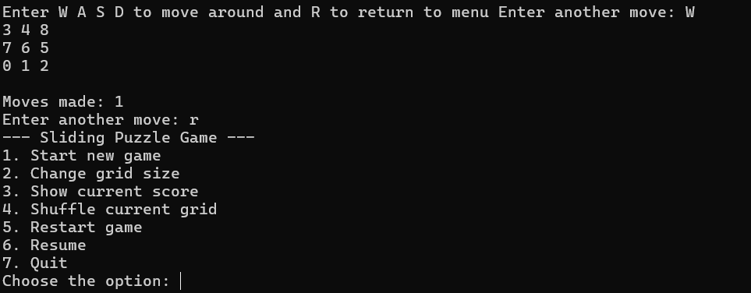

Step 6:
This program is useless without a way to check if the player actually won or not. That’s why we use a bool value that tells us if the player won or not. In the win_checker() function we first see if there is a 0 at the end of the grid (so that it’s not at the top), then we go through the grid to make sure if the numbers are in an ascending order (We might reach the end where it isn’t ascending, but just the 0 empty tile so we also write an else if for that). If the loop finds something wrong it gives the bool value 0 and breaks out of the function. We then return this value for the main while function in game().
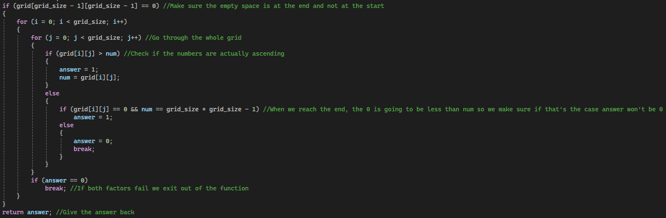

Step 7:
A game is no fun if we can’t save our high scores that’s why we need a global variable high_scores array that can save our high scores. For this we first need to check if the score is actually the highest (lowest actuallym, because the lower amount of moves the better). We use the update_high_scores() function which uses a switch case to assign different sizes to the different elements of the array, while checking if the new score is actually smaller than the older.
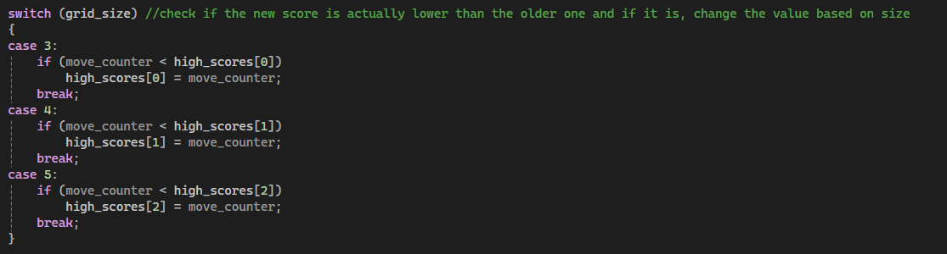
After it gets updated then we are able to display it to the user using show_curent_score() function. In here we have to make sure that if the value is still INT_MAX we just say NONE, otherwise just print out the values and then ask the player if they want to continue or not.
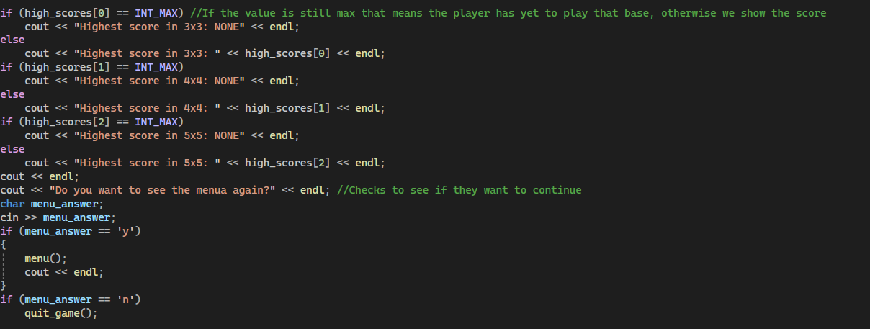
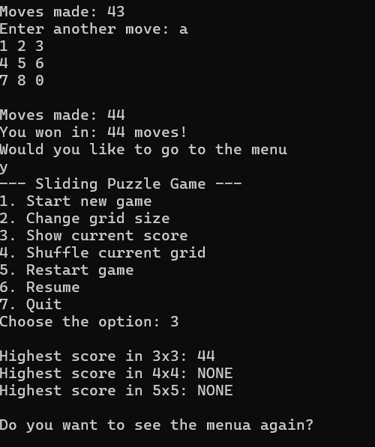
Step 8:
At the end we just add some basic functions for the menu, such as new_game() which resets the high scores and starts up a game
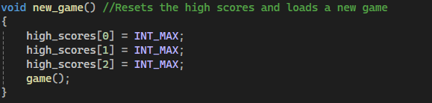
Resume() which just returns back to the while loop, which hasn’t been quit out yet.
Restart() which restarts the game by calling the new game function.
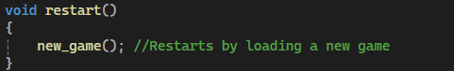
And at last quit_game() which gives a goodbye message and quits out of the program.
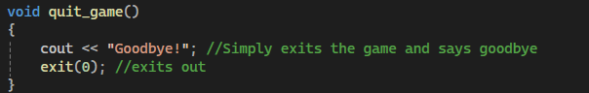
In the int_main() function all we really need to run is the menu() function and everything else will be handled by the functions.

